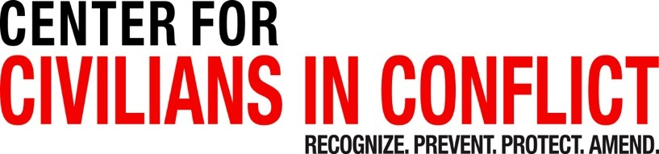

United Nations Security Council Open Debate on the Protection of Civilians in Armed Conflict

Statement delivered by Mr. Hichem Khadhraoui, Executive Director, Center for Civilians in Conflict (CIVIC)

May 21, 2024

New York, NY

Check against delivery

Thank you, Mister President, and thank you Mozambique for inviting me to address the Security Council at this important Open Debate.

Excellencies, Ladies and Gentlemen,

It is an honor to address the Security Council on behalf of my organization, or CIVIC, as this Council marks twenty-five years since the protection of civilians became a priority on its agenda, and on the 75th anniversary of the Geneva Conventions.

A Yemeni woman told CIVIC: “We have never had any advance or early warning; we have no bunkers and we live in close proximity to military bases. We know anything may happen anytime and we live with this reality and fear on a daily basis.”

This mother is far from alone in this fear. As wars grow longer and deadlier, civilians are constantly harmed and targeted by armed actors with no safe place to go.

[Mister] President

Twenty-five years ago, the protection of civilians came into being at the UN as a promising tool of the international system to reduce the suffering caused by armed conflict.

Yet today, civilians face higher risks than ever. State and non-state actors are targeting civilians, violating international humanitarian law with devastating consequences for civilians. Civilian casualties are sometimes referred to as the acceptable “collateral damage” of war. They are killed, displaced, and subjected to sexual and gender-based violence and starvation. Technology and disinformation are being weaponized to directly cause harm and fuel conflict.

I would like to highlight a few worrying trends confronting civilians:

Attacks against humanitarian workers: 2023 saw a death toll of 264 humanitarian colleagues who lost their lives while seeking to protect civilians trapped in conflicts. The 191st UN staff member was killed in Gaza last week. As a result, civilians are denied access to the most basic services, access to food, health and water.

The use of explosive weapons in densely populated areas: When such explosive weapons are used, civilians represent up to 90% of those wounded and killed. Civilian deaths caused by explosive weapons increased by 122% last year. States still use cluster munitions despite their well-known devastating effects on civilians. Schools, hospitals, water, and sanitation facilities continue to be targeted - leaving entire areas uninhabitable and driving displacement.

The privatization of war: States are outsourcing security roles to private military and security companies, in some cases, escaping accountability for harm to civilians. A growing body of research, including ours, links some of these actors to the commission of atrocities, conflict-related sexual violence, and human trafficking. These violations often occur with the tacit acceptance of States.

5. Arms transfers and global military expenditures: over 2.4 trillion US dollars were spent in 2023. States export arms around the world, while failing to ensure that those weapons aren’t used where there is an overriding risk of the commission of violations of international humanitarian law. In doing so, States are creating the conditions for more prolonged conflict and increased civilian harm worldwide.

But I believe there is still hope. Courageous civilians and communities are finding ways to survive amidst massive human suffering. Humanitarian workers, peacekeepers make tremendous sacrifices to protect civilians where they can. Some national leaders and forward-looking Member States are placing protection of civilians at the top of their agendas.

This week, 23 NGOs signed a Joint Statement that stressed the need to urgently close accountability gaps. We must have the political courage and temerity to defend the protection of civilians as a shared goal.

[Mister] President,

On this 25th anniversary, I propose three concrete actions to advance this cause:

First, every UN Member State must endorse and fully implement the Political Declaration on Strengthening the Protection of Civilians from the Humanitarian Consequences of the Use of Explosive Weapons in Populated Areas.

Second, Member States must immediately end the supply of weapons to partners where there is an overriding risk of facilitating violations of international humanitarian law.

Third, each State must develop a national POC policy, together with civil society and impacted communities. We need to bring IHL back where it belongs – to the people affected by armed conflict.

There's ample reason and opportunity to profoundly alter our approach. The UN Security Council must take the lead in ensuring accountability, fighting impunity, and in avoiding double standards. Reversing the tide of civilian harm in armed conflict is not only a legal and moral responsibility but is central to maintaining international peace and security and strengthening the world economy.

We cannot allow this 25th anniversary to pass without seizing the opportunity to do better. Civilians around the globe are watching us, their lives depend on our actions today. Let’s be accountable, let’s be responsible. We must not let them down.

END

